1. Is it possible that an event is independent of itself? If so, when?

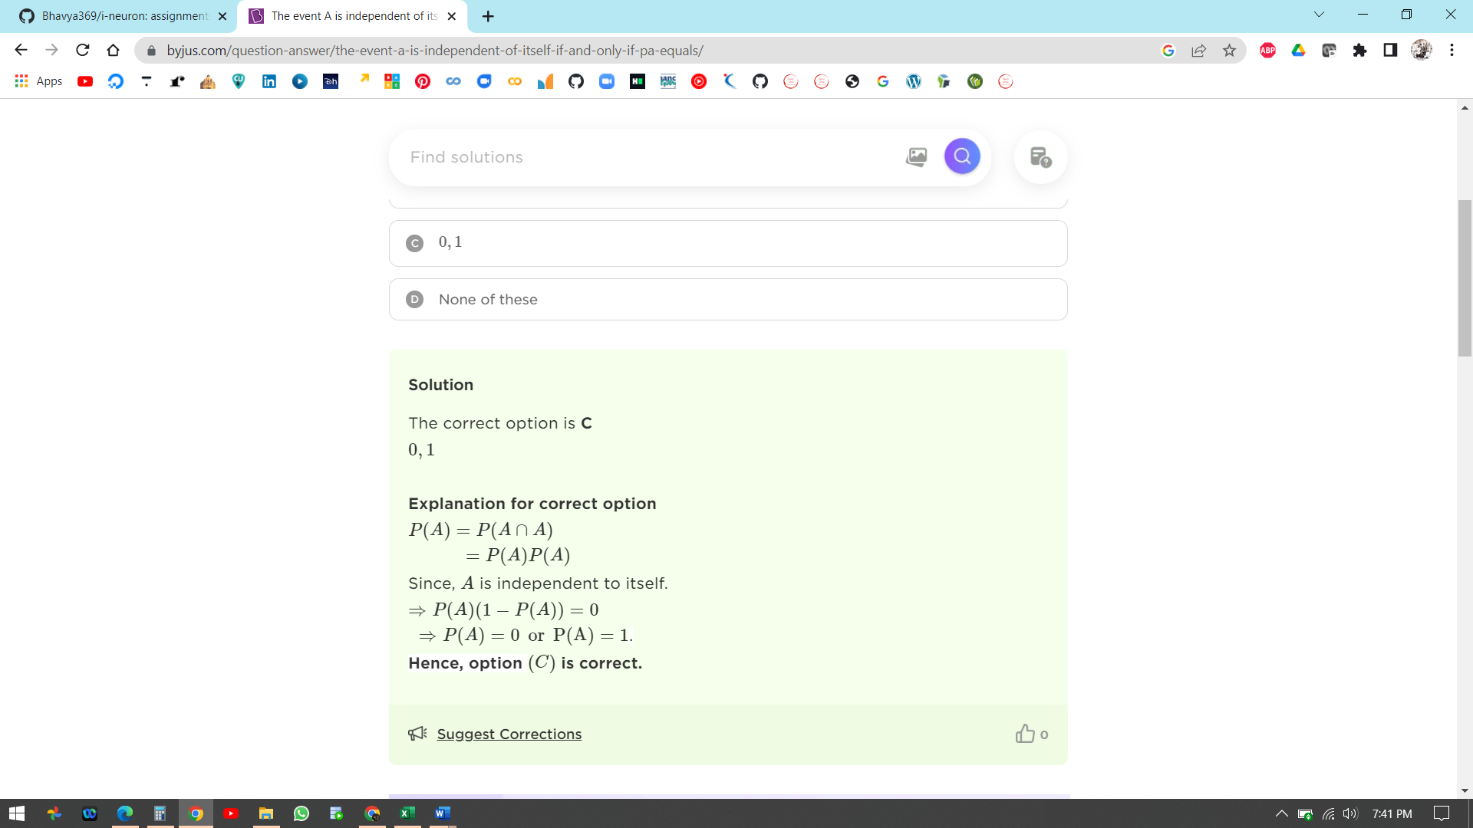

1. Is it always true that if A and B are independent events, then Ac and Bc are independent events? Show that it is, or give a counterexample.

